Peter Victoratos

CSC 411

Homework 2: Fruit Finder

1. Introduction

The objective of this assignment is to write code that can locate and draw contours around fruit (specifically apples, oranges and bananas) in an image. Python allows us to analyze images and determine the intensity of the channels of our selected color space. Since we want to find three different kinds of fruit based on its color, the image has to be split into its channels and a mask must be applied to each color. This can be difficult as the three fruit have colors that are close on the color wheel. There are also some shared green hues on some of the oranges and bananas. Differentiating between these can be difficult, so I utilized using different spaces for each fruit and different threshold values.

1. Method

The program does so by creating a separate mask for each fruit shape and color. Masks were made by first brightening the image and converting it to HSV. By brightening it, colors are stronger and the fruit finder (should) have a better time differentiating between fruit. I only used the hue and saturation values for the red and yellow masks since the orange hue values were so distinct. My finder did okay just using the saturation channel for the bananas. Below are my masks and their components, they are not perfect but can catch just enough color to find each fruit. I also disregarded the images of the fruit on the black background and built my code using the mixed_fruit images.

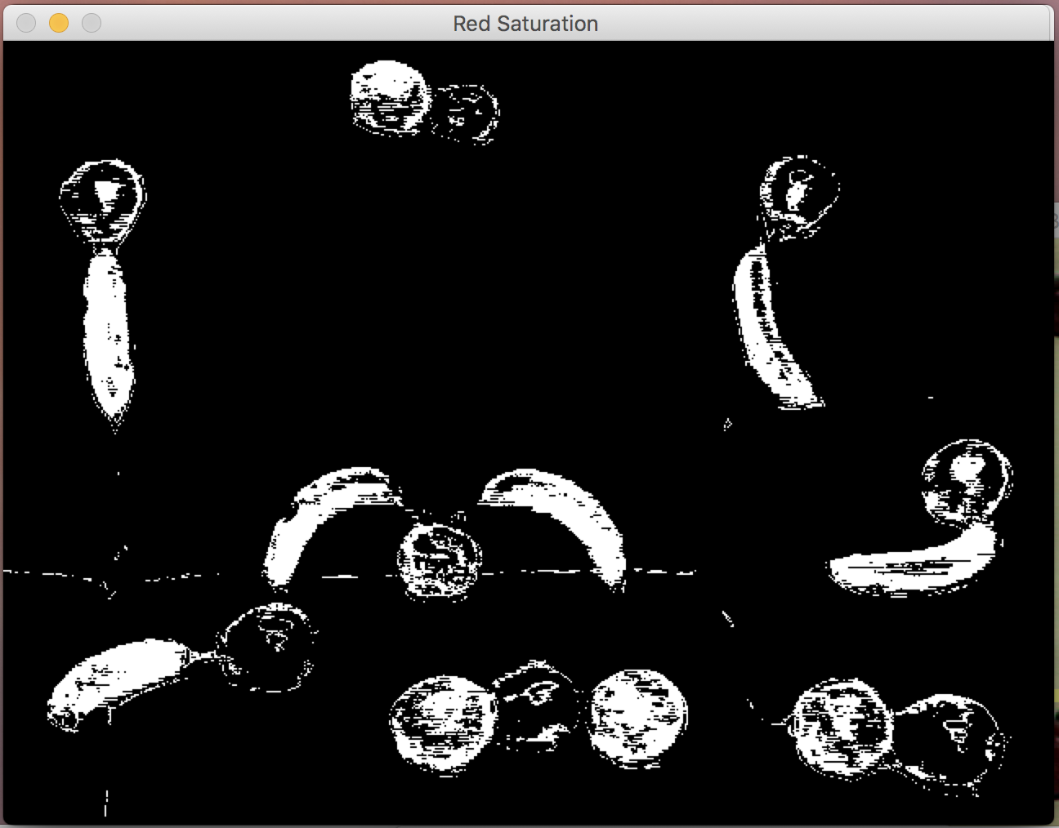

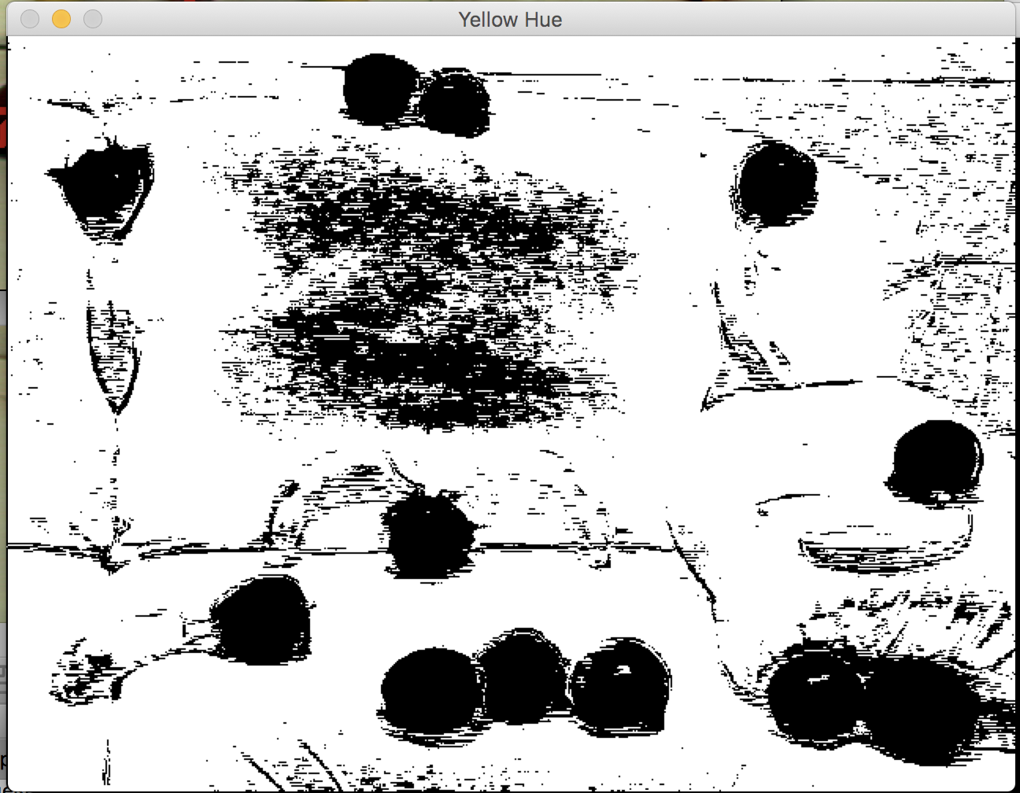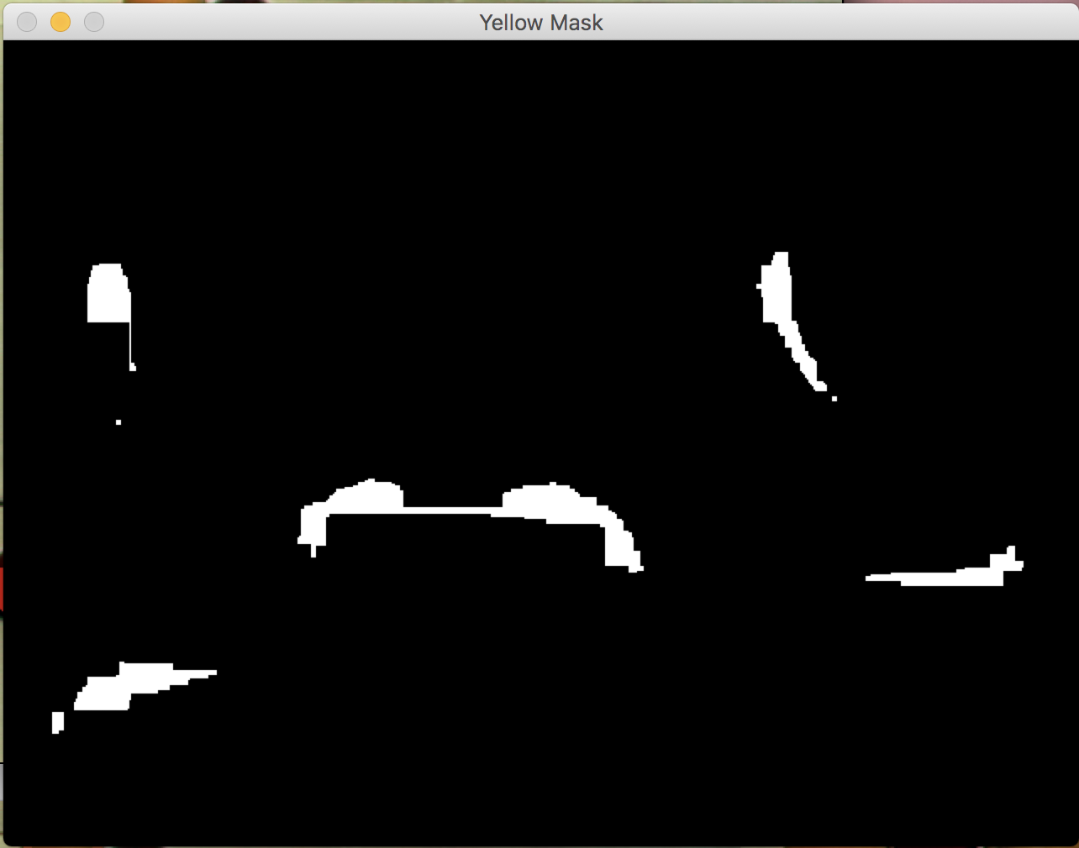

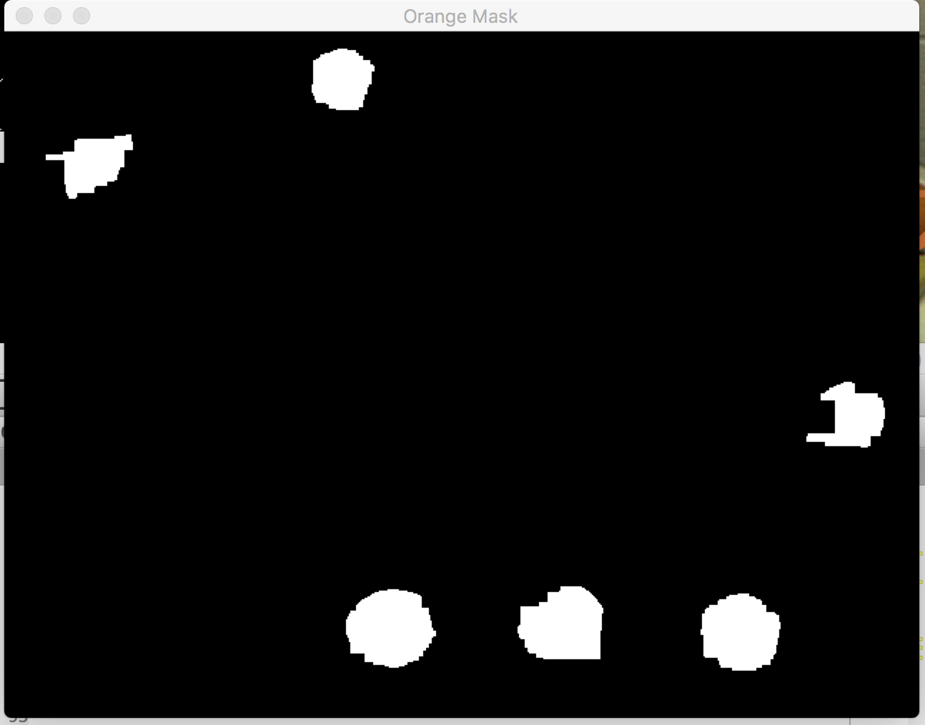

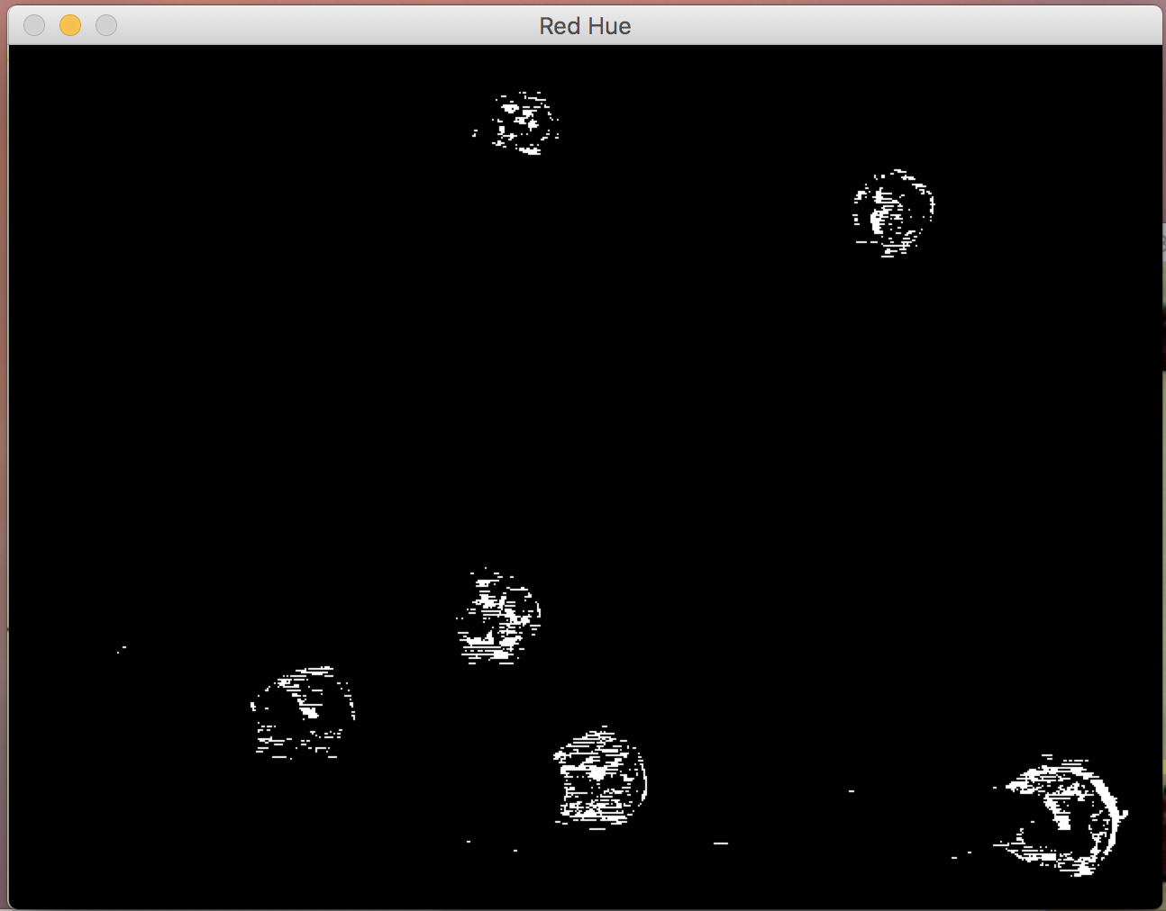

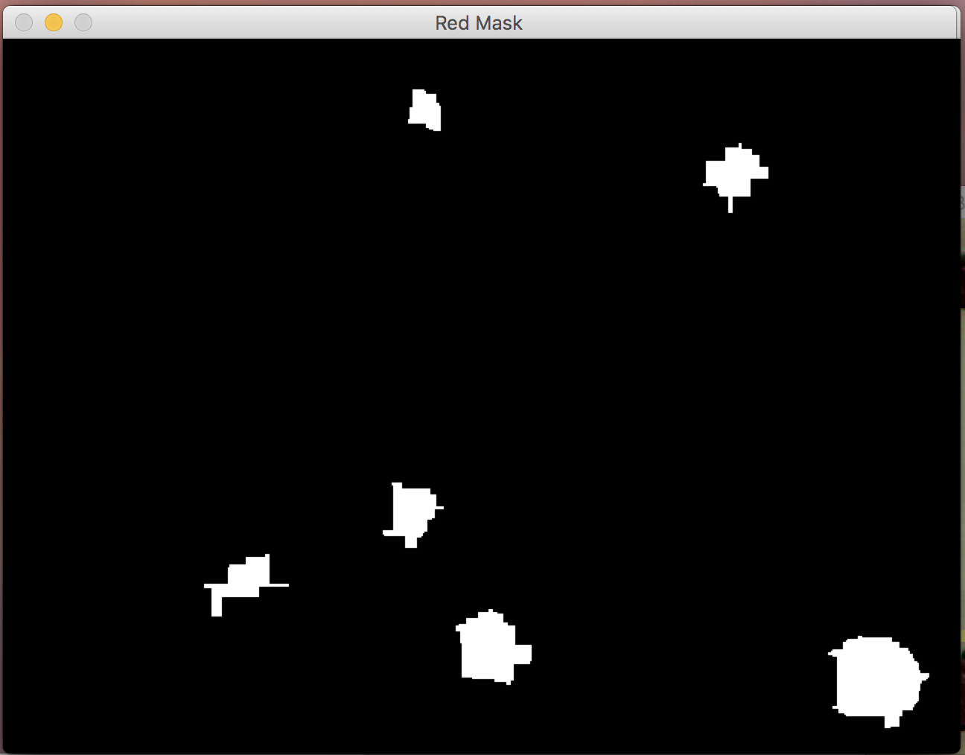

The red mask worked the best. It has the least amount of random white noise which the finder would pick up and count as a fruit.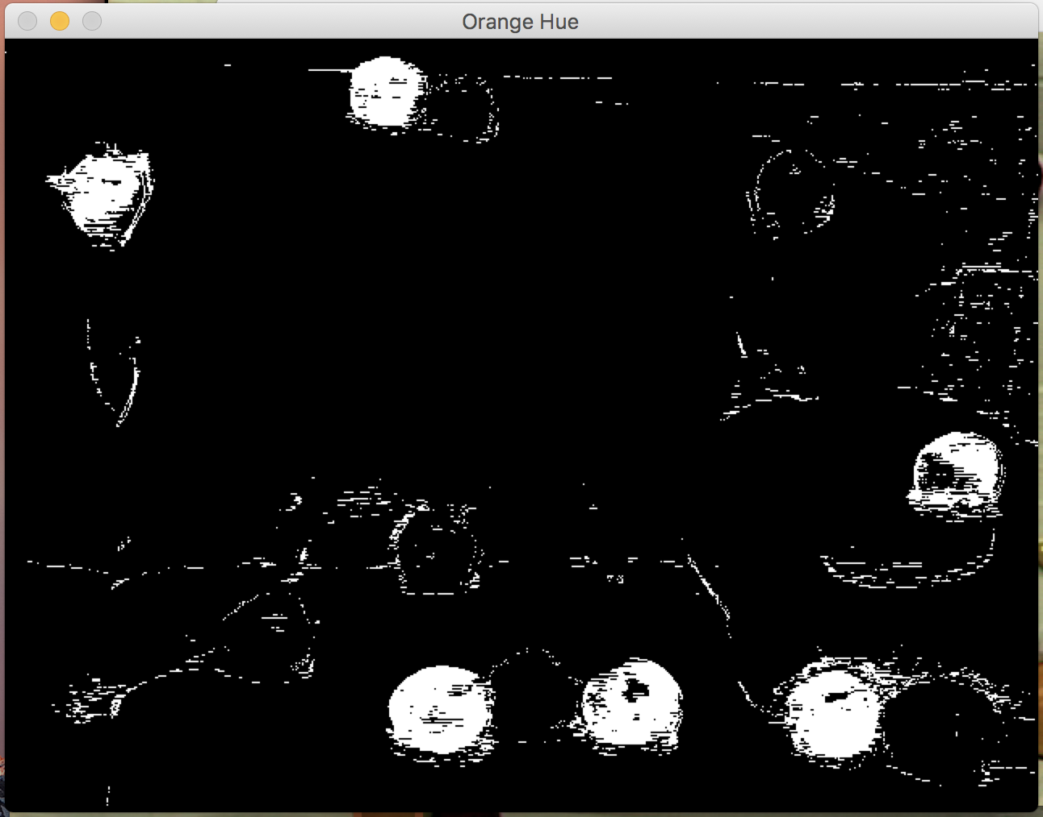



My orange hue mask did a good job at finding the oranges however in some cases it would pick up small parts of bananas in the images where they had some green in them.

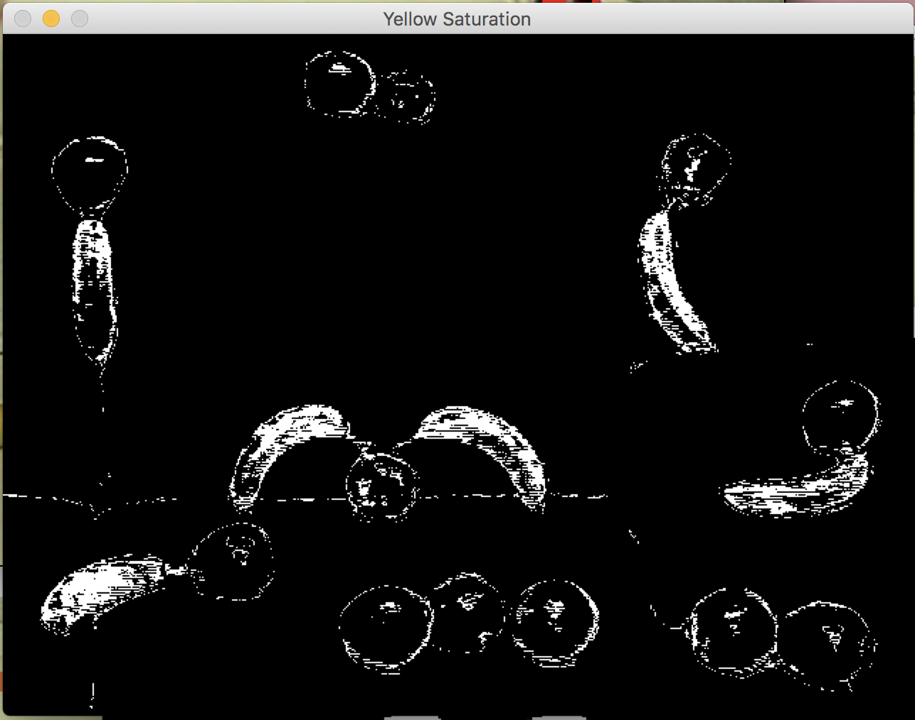



My yellow finder definitely performed the worst of the three. I think this is because my hue channel is picking up the wrong shapes, similarity in some of the hues in the oranges and when it came time to clean up the mask, I made my morphological function into a horizontal rectangle to get the bananas that are lying down better. This may have worked for one image but obviously does not apply to them all since the bananas are in different orientations. There is also some white noise (seen above) that I couldn’t remove. If I fixed my hue channel for the yellow and maybe added and rgb mask, the finder would be better at doing its job.

3. Results

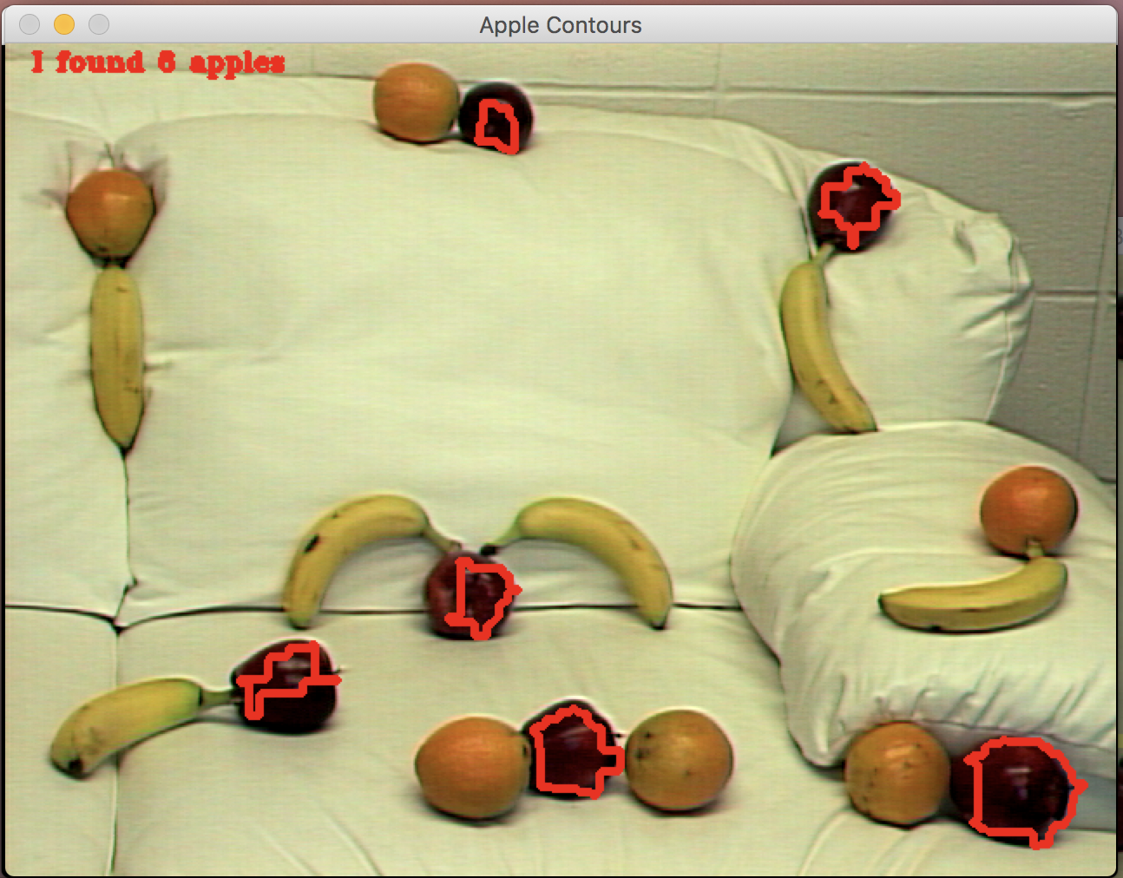

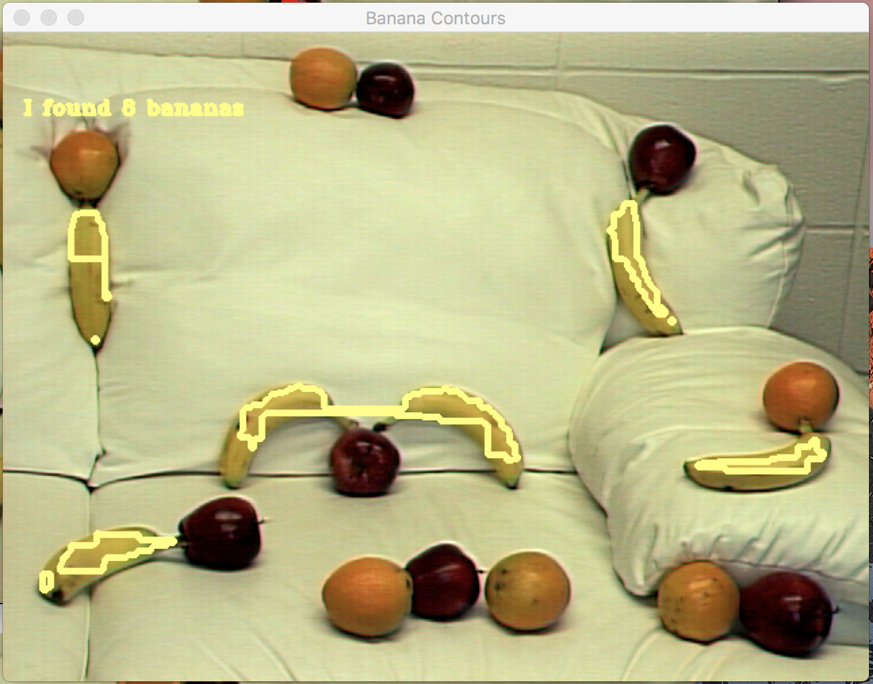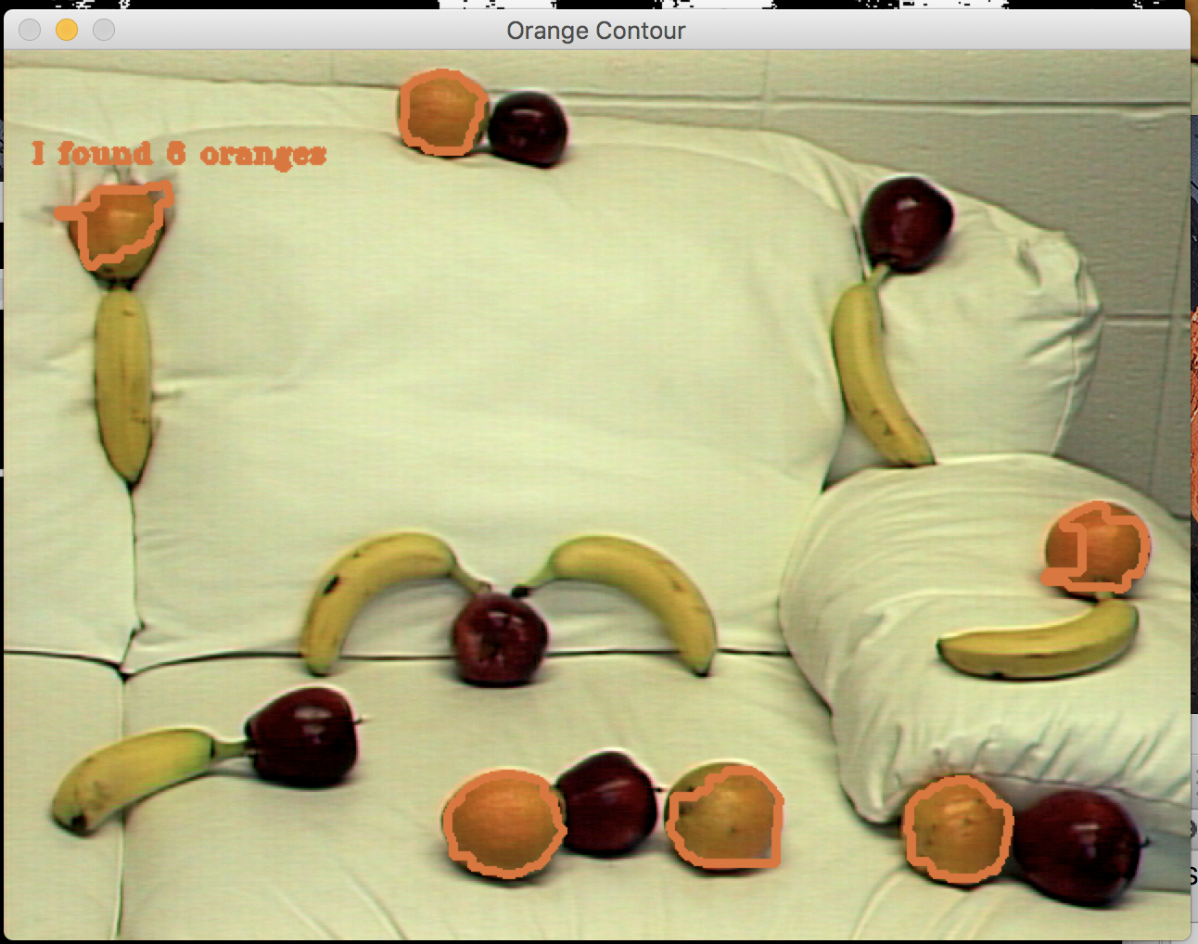

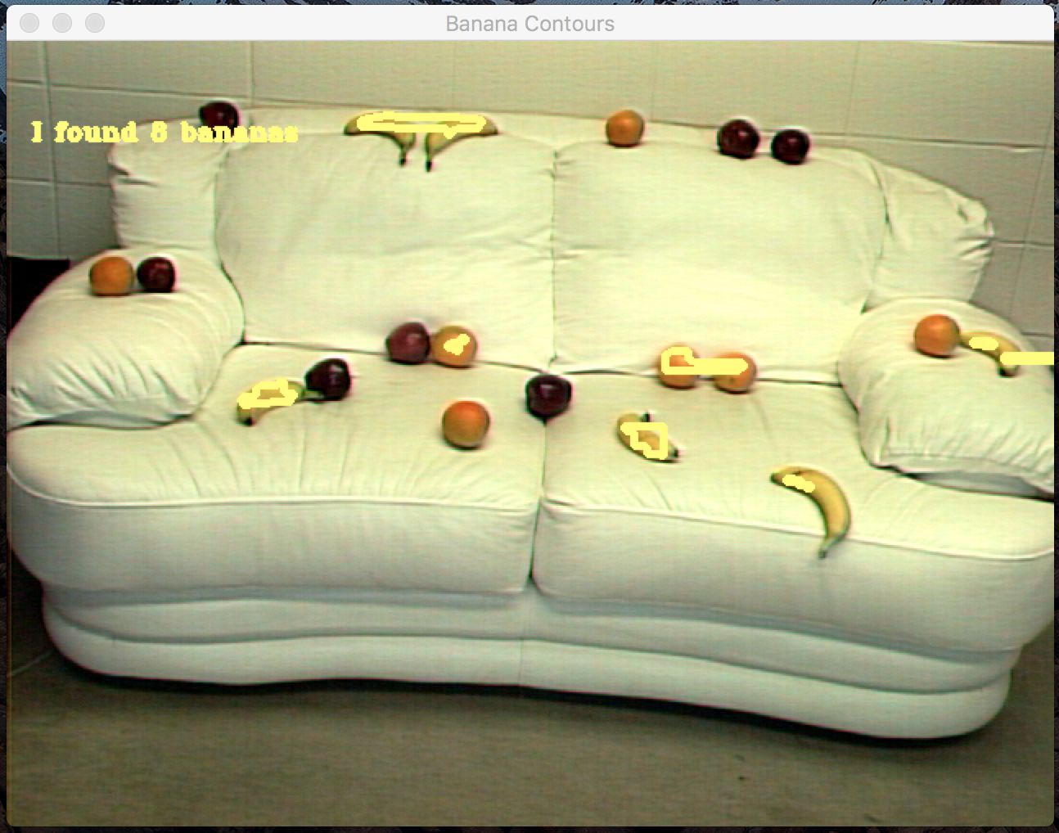

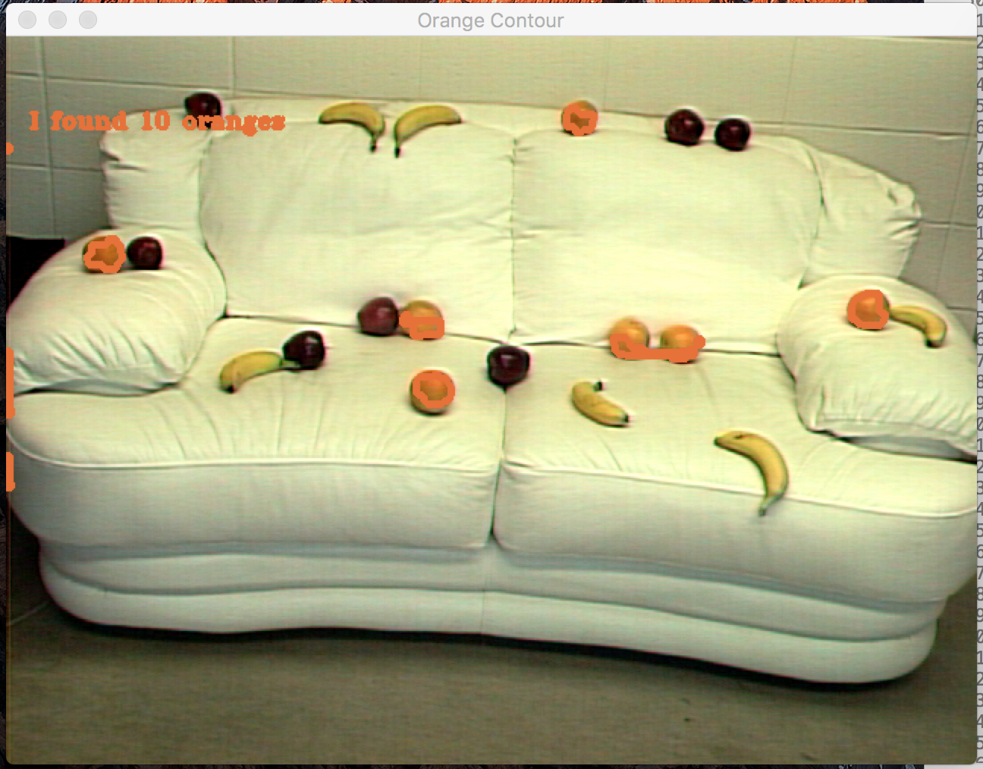

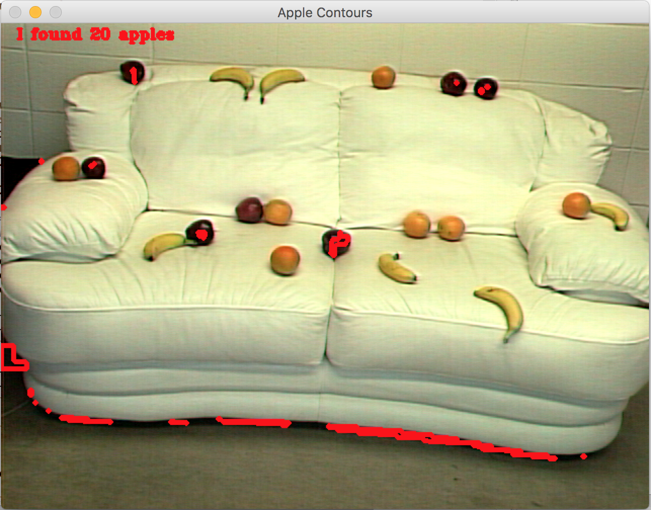

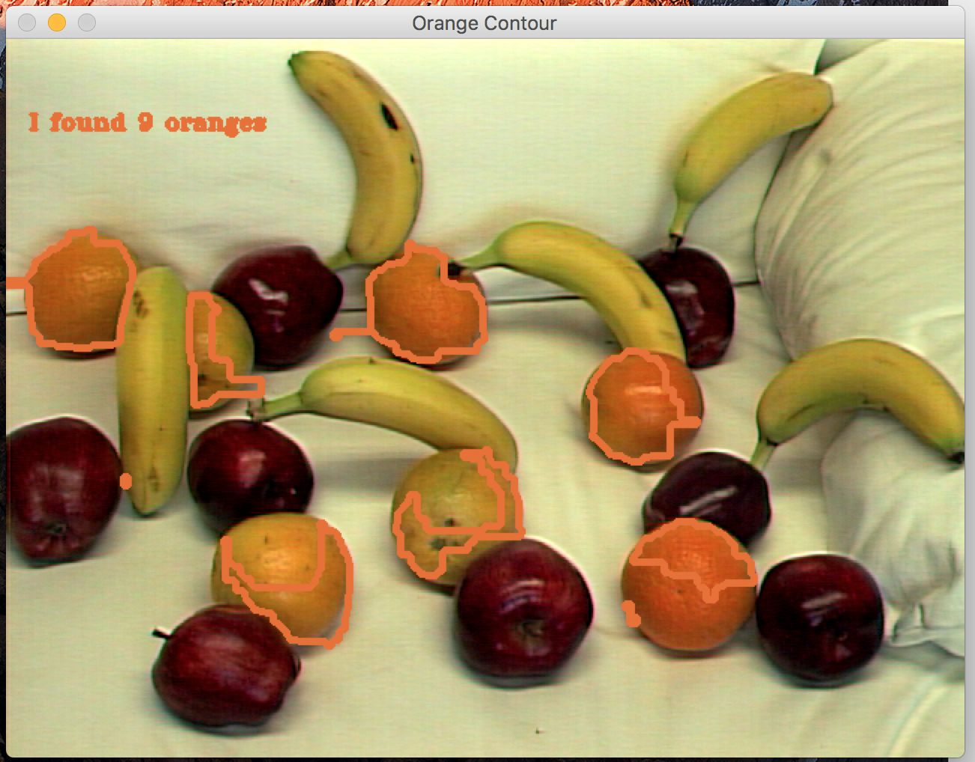

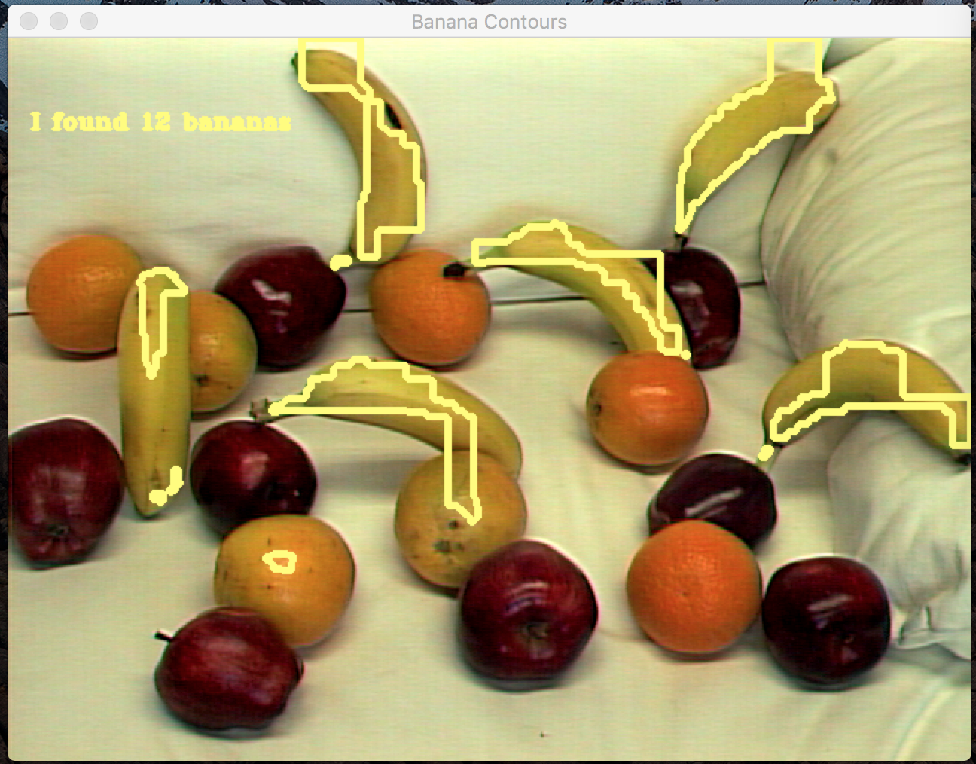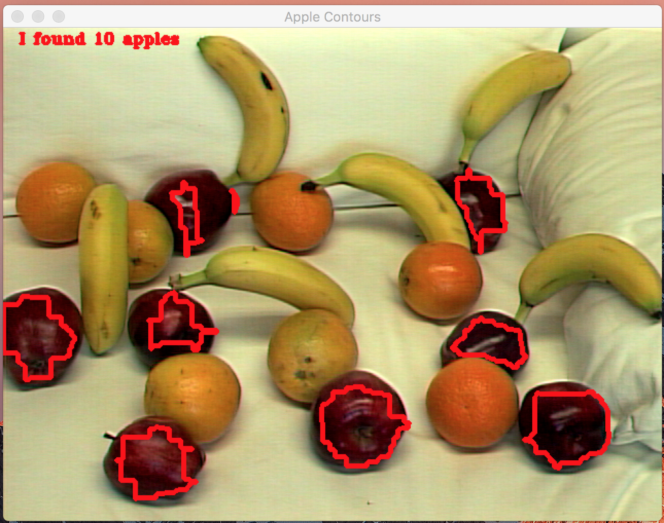

4. Conclusion/Discussion

Looking back at this project, I definitely could have gone about it more strategically so that my finder would get better results. I could have done so by utilizing the fruit on black images as well as keeping a better record of my threshold values. It was really easy to just sit there and keeping altering them a bit until better results would be shown. However this isn’t the best approach since the fruit changes in every picture. It picks up chunks of the fruit but easily overcounts by picking up other random parts of the image. In the mixed_fruit1.tiff test for the apples, it counted the shadow underneath the couch as a bunch of apples. The darkness of the shadow resembled the darker shades of the apples. I also couldn’t write the code snippet that puts the text on the fruit it counts, so I settled for a little sentence at the top. If it did correctly count the number of fruit, it keeps track (however most of my examples did not correctly count them). Since I made the program brighten the image, it would not read in the fruit_tray.gif file. Adding the brightness was something I did towards the end so going back to check the fruit tray would require some changes to my code. I definitely didn’t do my best on this homework in terms of execution. I understand the topics covered (thresholding, contouring, morphology, etc.) but I didn’t balance my time wisely this week. I’m hoping for next week to start earlier and be as successful as my first homework.

I also want to know how to set the text to the centers of each bounding box around the fruit. Still didn’t get that from the pumpkin lab.